Ivy Tech PLC Trainers

Submitted by:
Charity Fischer

Date of Submission:
September 10, 2019

Submitted to:
Ms. Caitlin M. Cramer

Summary
Charity Fischer has been tasked with the project of building 3 PLC trainers for the purpose of teaching for the following Spring semester at Ivy Tech Community College Fort Wayne. The proposed trainers are each supposed to have a minimum of 8 push buttons, 4 toggle switches, and 12 lights, and must include an emergency stop button and have the ability to connect external outputs.
Timeline
The schedule is planned as follows:
Week of:
9/23 - Trainer parts are ordered, final PLC trainer design is complete
9/30 - Housing assemblies are built, parts arrive
10/7 - First PLC trainer is built and tested
10/14 - Final PLC trainers are built and tested
Project will be complete on October 18th, 2019
Design
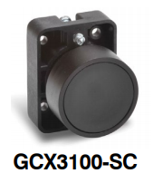
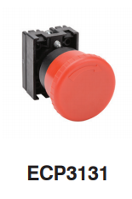
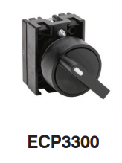
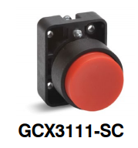
The proposed trainers will be approx. 195mm wide and approx. 450mm tall with the pushbuttons in rows of 4 on the top third of the trainers. Black, flush normally closed in the first row and red, extended normally open in the second row (GCX3100-SC and GCX3111-SC on p. 4 of attached GCX Series Pushbutton pdf from automationdirect.com respectively.) In the third row will be the 4 2-position toggle switches (ECP3300 on p. 1 of attached Selector Switches pdf from automationdirect.com.) All the pushbuttons and toggle switches will be 30mm in diameter. In the middle of the trainers will be the PLC unit. In the bottom third of the trainers will be the 12 lights in rows of 4 red, orange, then green. Left of the PLC will be the red emergency stop button below the on-off switch (ECP3131 on p. 1 of attached Mushroom Pushbutton pdf from automationdirect.com.)
Budget
The pushbuttons on rows 1 and 2 are $2.50 each on automationdirect.com making the total for 8 pushbuttons $20. The toggle switches are $4.50 each making the price for 4 of them $18. The emergency stop button is $6.50.. The total price of pushbuttons and switches (minus the on-off switches), for 3 PLC trainers from automationdirect.com is $133.50.
Remaining lights, housing assembly parts, and PLC units for trainers will be found on Ivy Tech campus.

